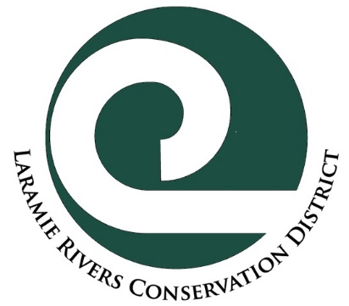
Laramie Rivers Conservation District
Soil, Water, and Plant Analysis Cost Share Program
General Program Objectives
This program provides incentive for residents to understand their natural resources by cost sharing on expenses for analysis at recognized analytical labs.
Who is Eligible:
Albany County residents, businesses, and landowners
Project Examples
- Soil analysis for gardens or crops, for nutrient information or contamination
- Potable/Irrigation/Livestock water analysis
- Trace metals in water
- Forage analysis for nutritional value
Ineligible Project
- Any analysis on a third party’s property without their written permission
Funding
The Cost Share program matches up to 50% of project costs. This is a reimbursement of cost paid to the applicant after the project is complete.
- Maximum match is 50% of project cost, up to $250.00.
- Soil, water, and plant Analysis Cost-Share request with a 50% match of over $250.00 may be applied for with the Rural Cost-Share program
- Applicants can apply once per calendar year (January 1st to December 31st )
Criteria for Cost Share
For a project to be eligible for LRCD cost share funds, a project must:
- Clearly meet objectives of this program.
- Contact LRCD staff to discuss your objectives and what kind of analyses may be needed.
- Be approved by LRCD staff before samples are taken to lab.
- Be fully completed within one year of approval.
- Be approved on a first-come, first-served basis.

Application and Program Procedure
- Self-assessment: does your proposed project meet the objectives of this program?
- Contact LRCD staff to determine if project meets the criteria.
- Select a lab, get cost estimates, and apply for cost share.
- LRCD staff reviews and authorizes Application/Agreement
- Complete work as described in the Application/Agreement.
- Turn in: 1) receipts; 2) reimbursement worksheet 3) tax form, if required; and 4) signed Agreement Completion Certification.
- LRCD Board of Supervisors reviews completed project and authorizes reimbursement.
- You should receive reimbursement check by mail within 15 days of monthly board meeting.
THE LRCD BOARD OF SUPERVISORS RESERVES THE RIGHT TO DECIDE WHETHER PROPOSED COSTS ARE REASONABLE AND WHETHER A PROJECT DESIGN IS APPROPRIATE.

Laramie Rivers Conservation District
Analysis Cost Share
Application and Agreement Form

Applicant Name: __________________________________________________________ Date: ___________________

Or Company Name:______________________________________ Represented by: ____________________________
(Name/Title)
Mailing Address: __________________________________________________________________________________

Project address if different: ___________________________________________________________________________

Phone: ____________________________________ Email:_________________________________________________
Do you own ☐or rent☐
Project category (check those that apply)
☐Water portability (bacteria and salts, nutrients) ☐Forage nutrition (i.e.: protein in hay)
☐Water for irrigation/livestock (salts) ☐Trace/heavy metal in soils
☐Soil for gardening (soil nutrients) ☐Trace/heavy metal in water
☐Other (specify)_____________________________

Justification for project – State the situation leading to your need for analyses:

Estimated project total: $ Attach detailed budget-LRCD does not cost share on the sales tax

50% cost share request: $
Staff comments:
Public benefit:  conservation of natural resources  promotion of health/safety of citizens
 protection of the tax base

APPLICATION AND APPROVAL

___________________________________________________________ Date:_________________________
Signature of Applicant

___________________________________________________________ Date:_________________________
Signature of Landowner (if Applicant is Lessee/Renter)

___________________________________________________________ Date:_________________________
Application Approval by District Staff

PURCHASES MADE BEFORE APPROVAL MAY NOT BE ELIGIBLE FOR COST SHARE!
PLEASE NOTE THAT COST SHARE FUNDS MAY BE SUBJECT TO FEDERAL INCOME TAX!
__________________________________________________________________________________________
Agreement Completion Certificate (must be signed prior to payment)
I hereby certify that implementation of the conservation practices proposed in the Application/Agreement have been completed according to the Objectives and Criteria of this program as of the date shown below. The receipts I provided reflect the true cost of implementing the project authorized.

________________________________________________________________________________________________
Signature of Applicant Date

_________________________________________________________________________________________________
Signature of Landowner (if Applicant is Lessee/Renter) Date

_________________________________________________________________________________________________
Project confirmed by LRCD staff Date

Date Reimbursement Approved:_______________________

